User Story-001

Testcase -002 : Navigation of URL in Chrome Browser

Step1: Open the Mozilla Firefox browser and enter the URL of the OpenCart <https://demo.opencart.com/>

Step2: Enter the URL of the OpenCart <https://demo.opencart.com/> and **press** **Enter**

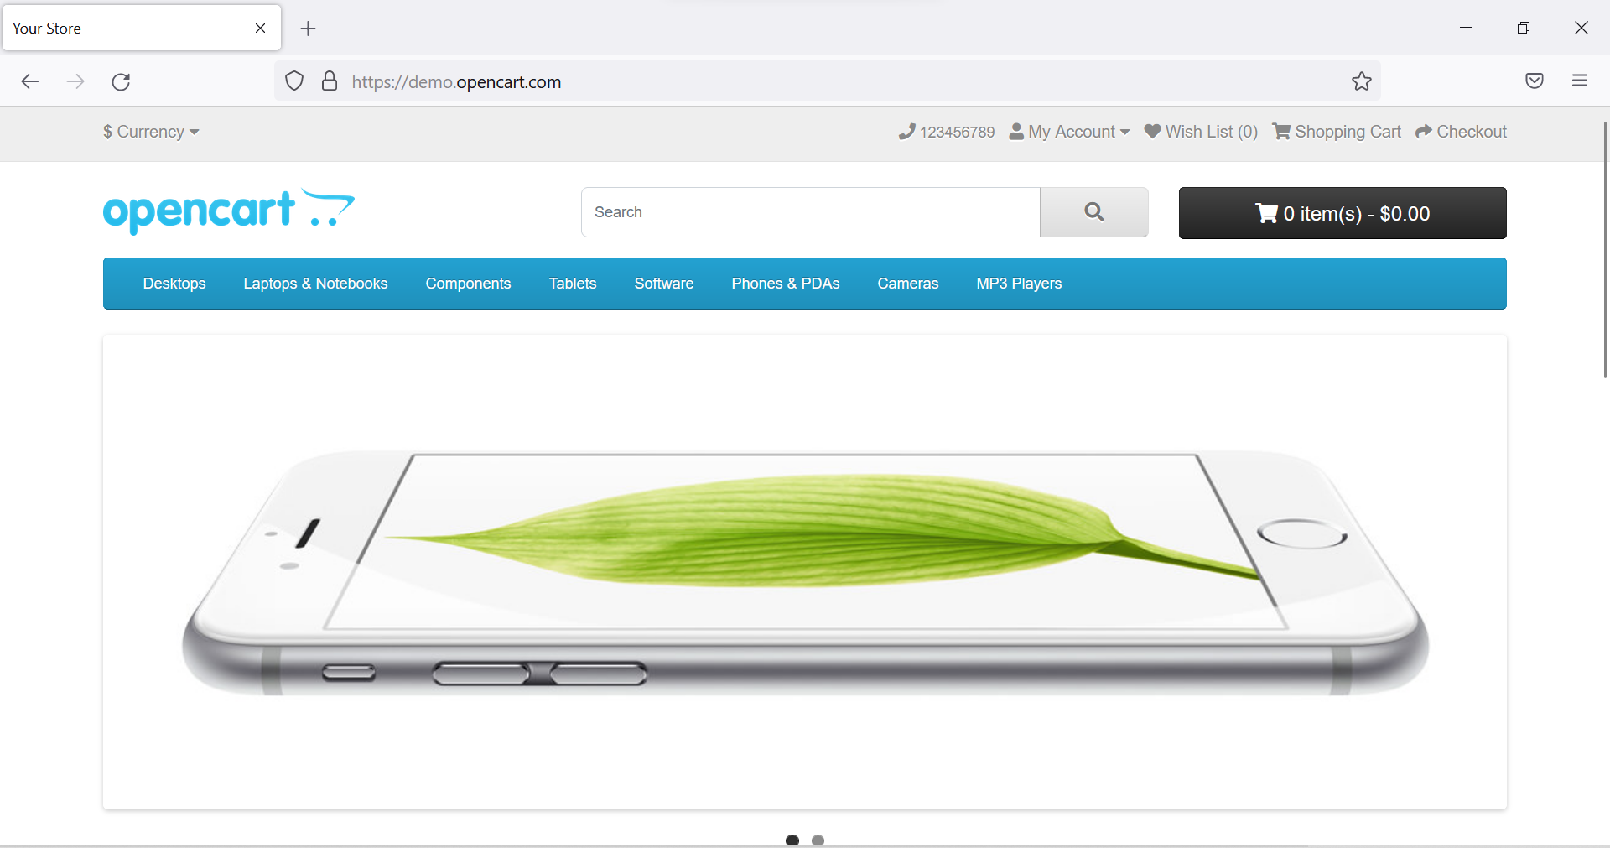

**All the steps are not passed and testcase-002 has a defect as its opening in other browser also.**